Smart Parking Platform
Project Management Plan
Prepared by Anas Altaf, CTO — WE ARE $oftware Corp.
Homework 1 — Research, Vision & Scope, and Draft SRS
CIS 4374 / TLIM 3355 — Dr. Otto Dobretsberger

Table of Contents

1. Research: Competitive Landscape Analysis
Before defining the Smart Parking Platform in detail, WE ARE $oftware Corp. conducted a review of existing parking solutions currently in use across major U.S. markets. This analysis identifies what already exists, where those platforms fall short, and how the Smart Parking Platform can differentiate itself. The review focused on the four platforms most commonly cited as market leaders: SpotHero, ParkWhiz, ParkMobile, and PayByPhone.

1.1 Existing Solutions Overview
Platform | Core Focus | Strengths | Weaknesses / Gaps
SpotHero | Pre-booked garage & lot reservations | Large network of garages across North America; dynamic pricing typically well below drive-up rates; strong presence at event venues and airports. | Inventory limited to commercial garages and lots — no street parking or residential spots; limited real-time occupancy granularity once a facility nears capacity.
ParkWhiz | Pre-booked garage & lot reservations, event/airport focus | Guaranteed spot reservations with mobile entry that skips lines; strong event-day and airport parking coverage; data/API integrations for facility owners. | Similar coverage gaps as SpotHero for street parking; pricing can rise sharply during high-demand events, with fewer alternatives shown to the driver.
ParkMobile | Pay-by-phone metered and municipal lot parking | Largest footprint by number of zones/spaces in the U.S.; simple pay-per-session model; strong municipal partnerships for on-street parking. | Charges a per-transaction convenience fee; weaker support for advance reservations in commercial garages; session/GPS syncing issues reported by users when ending a session early.
PayByPhone | Municipal meter and pay-per-session parking | Widely adopted as the official meter partner in many cities; straightforward session-based payment flow. | Coverage depends entirely on which city has adopted it as the official provider; minimal reservation or navigation features compared to garage-focused apps.
Table 1. Summary of leading parking platforms currently in the market.

1.2 Key Gaps Identified
- Fragmentation: drivers currently need multiple apps to cover both on-street metered parking and off-street garage reservations — no single platform unifies both experiences well.
- Limited real-time granularity: several platforms show a facility as "available" without reflecting live occupancy changes as spaces fill up throughout the day.
- Thin operator tooling: reservation platforms are optimized for the driver-facing experience, while operator-side occupancy reporting, dynamic pricing controls, and analytics are comparatively basic.
- Fee transparency: convenience fees and surge pricing are frequently cited as a source of user frustration, with the total charged at checkout differing from the price shown during search.

1.3 Differentiation Opportunities
The Smart Parking Platform will differentiate itself by unifying real-time garage reservations and navigation within a single application, giving parking operators a genuinely robust administrative dashboard (occupancy analytics, dynamic pricing, and reporting) rather than a bolt-on afterthought, and committing to upfront, all-inclusive pricing at the point of search rather than at checkout. Because WE ARE $oftware Corp. operates under a theoretically unlimited development budget, the platform can also invest more heavily in the reliability of real-time availability data and third-party mapping integration than competitors who are more cost-constrained.

2. Vision and Scope

2.1 Project Origin
WE ARE $oftware Corp. was engaged after a coalition of mid-sized city transportation departments issued a joint request for proposals (RFP) seeking a unified platform to reduce downtown congestion caused by drivers circling in search of parking. Existing point solutions in the market addressed only pieces of the problem — payment, reservations, or navigation individually — and no vendor offered an end-to-end platform covering both the driver experience and operator-side management tools. WE ARE $oftware Corp. was selected based on its proposed unified architecture and its ability to commit development resources without the budget constraints that limited competing bids.

2.2 Company Introduction
WE ARE $oftware Corp. is a software development studio positioned to take on ambitious, resource-intensive builds without the typical constraints of budget. The company's structure centers on cross-functional delivery teams — Mobile, Web, Backend/API, Mapping & Location Services, Payment Integration, and Quality Assurance & Testing — organized to move in parallel on a single coordinated release plan rather than in strict sequence. This structure is intended to compress the delivery timeline for the Smart Parking Platform despite the fixed semester-length schedule.

2.3 Project Overview
The Smart Parking Platform is a web and mobile system that allows drivers to locate, reserve, and pay for parking spaces in real time, while giving parking facility operators the tools to monitor occupancy, adjust pricing, and improve utilization of their assets. The platform addresses a well-documented urban problem: drivers spend significant time searching for available parking, which contributes to congestion, driver frustration, and lost productivity, while operators lack modern tools to manage and optimize their existing capacity.

2.4 In Scope
- Driver-facing web and mobile applications covering registration, search, reservation, payment, and navigation.
- Operator-facing administrative dashboard covering facility management, pricing, and occupancy analytics.
- Integration with third-party mapping/navigation services and third-party payment processors.
- Notification and alerting system for reservation and account activity.

2.5 Out of Scope (Initial Release)
- Hardware installation at parking facilities (e.g., physical gate sensors or license-plate cameras) — assumed to be handled by each facility's existing infrastructure or a future phase.
- Direct integration with municipal on-street meter systems — the initial release focuses on off-street garage and lot facilities.
This scope will be refined in subsequent weekly updates to this document as requirements elicitation continues.

3. Draft Software Requirements Specification (SRS)
This section presents the initial draft of the Software Requirements Specification for the Smart Parking Platform, expressed as a set of use cases derived from the high-level requirements and stakeholder groups identified to date. Each use case identifies the primary actor, the triggering condition, a summary of the main flow, and the resulting postcondition. This draft satisfies the minimum of 15 use cases and is expected to grow in both count and detail (including alternate and exception flows) as the project progresses through the semester.

3.1 Actors
- Driver — an individual searching for, reserving, and paying for parking.
- Parking Operator — staff responsible for managing a parking facility's listing, pricing, and availability.
- System Administrator — platform-level staff responsible for account and integration management.
- Finance/Billing Personnel — staff responsible for payment reconciliation and refunds.

3.2 Use Case Inventory
ID | Use Case | Primary Actor | Trigger / Description | Main Flow (Summary) | Postcondition
UC-01 | Register Account | Driver | New user opens the app and elects to create an account. | 1) User provides name, email, phone, password. 2) System validates input and checks for duplicates. 3) System creates account and sends confirmation. | Driver has an active account and can log in.
UC-02 | Log In / Authenticate | Driver / Operator / Admin | Registered user opens the app or web portal. | 1) User enters credentials. 2) System validates credentials against stored records. 3) System grants role-based access. | User is authenticated and routed to the appropriate dashboard.
UC-03 | Search for Available Parking | Driver | Driver enters a destination or enables location services. | 1) System retrieves driver's location or entered address. 2) System queries real-time availability for nearby garages. 3) Results are ranked by distance, price, and availability. | Driver receives a list of nearby available parking options.
UC-04 | View Parking Locations on Interactive Map | Driver | Driver opens the map view from search results. | 1) System renders available garages as map pins. 2) Driver taps a pin to view pricing, distance, and availability. 3) Map updates in real time as occupancy changes. | Driver has a visual, real-time view of nearby parking options.
UC-05 | Reserve a Parking Space | Driver | Driver selects a specific garage and time window. | 1) Driver selects entry/exit time. 2) System checks space availability for that window. 3) System places a temporary hold on the space pending payment. | A reservation is created and held pending payment confirmation.
UC-06 | Make Digital Payment for Reservation | Driver | Driver confirms a reservation and proceeds to checkout. | 1) Driver selects a stored or new payment method. 2) System sends payment request to the payment processor. 3) System confirms payment and finalizes the reservation. | Reservation is confirmed and payment is recorded.
UC-07 | Cancel a Reservation | Driver | Driver opens an active reservation and selects cancel. | 1) System checks the cancellation window against operator policy. 2) System releases the held space. 3) System processes a refund if applicable. | Reservation is cancelled and the space is returned to available inventory.
UC-08 | View Reservation History and Receipts | Driver | Driver navigates to the reservation history screen. | 1) System retrieves past and current reservations tied to the account. 2) Driver selects a reservation. 3) System displays or exports a digital receipt. | Driver can view or download a record of past parking transactions.
UC-09 | Receive Notifications and Alerts | Driver | A reservation-related or system event occurs (e.g., reservation expiring, payment issue). | 1) System detects a triggering event. 2) System generates a notification. 3) Notification is pushed to the driver's device or email. | Driver is informed of time-sensitive account or reservation activity.
UC-10 | Navigate to Reserved Parking Garage | Driver | Driver selects "Navigate" from an active reservation. | 1) System passes garage coordinates to an external mapping/navigation service. 2) External service returns turn-by-turn directions. 3) App displays estimated arrival time. | Driver receives directions to the reserved garage entrance.
UC-11 | Log In to Operator Dashboard | Parking Operator | Operator opens the web-based management portal. | 1) Operator enters credentials. 2) System validates operator role and facility assignment. 3) System loads the operator dashboard. | Operator has access to facility-specific management tools.
UC-12 | Update Space Availability and Pricing | Parking Operator | Operator needs to adjust rates or block off spaces (e.g., maintenance, private event). | 1) Operator selects a facility. 2) Operator edits available space count or pricing rules. 3) System propagates changes to real-time availability shown to drivers. | Updated availability and pricing are reflected across the platform.
UC-13 | View Occupancy Reports and Analytics | Parking Operator | Operator requests a usage or revenue report. | 1) Operator selects a facility and date range. 2) System aggregates reservation and occupancy data. 3) System renders charts and summary metrics. | Operator receives actionable insight into utilization and revenue.
UC-14 | Manage Facility Listing | Parking Operator | Operator needs to add, edit, or deactivate a garage listing. | 1) Operator submits facility details (address, capacity, hours, amenities). 2) System validates and geocodes the address. 3) Listing becomes searchable to drivers upon approval. | Facility listing is created, updated, or deactivated on the platform.
UC-15 | Manage User Accounts | System Administrator | Admin needs to review, suspend, or modify a user or operator account. | 1) Admin searches for an account. 2) Admin reviews account activity and status. 3) Admin applies an action (edit, suspend, reinstate). | Account status is updated and the action is logged for audit purposes.
UC-16 | Configure Third-Party Integrations | System Administrator | Admin needs to add or update an external API (mapping, payment processor). | 1) Admin selects the integration to configure. 2) Admin enters or rotates API credentials. 3) System validates the connection. | Integration is active and available to the rest of the platform.
UC-17 | Process Refunds and Reconcile Transactions | Finance/Billing Personnel | A cancellation, dispute, or billing discrepancy requires manual review. | 1) Finance staff pulls the transaction record. 2) Staff verifies the refund or adjustment against policy. 3) System processes the refund through the payment processor and updates the ledger. | Transaction is reconciled and any refund is issued to the driver.
Table 2. Draft use case inventory for the Smart Parking Platform (17 use cases).

3.3 Notes for Future Iterations
- Add alternate and exception flows for each use case (e.g., payment failure, facility at capacity, expired session).
- Add non-functional requirements (performance, availability, security/privacy, compliance with city ordinance).
- Add data requirements and a preliminary data model once the Backend/API team's schema work begins.

4. Product Backlog and Sprint 1 Plan
With the draft SRS in place, WE ARE $oftware Corp. translated the use case inventory into a prioritized product backlog and planned the first development sprint. The backlog is maintained on a shared Trello board so that every delivery team works from a single, visible source of truth, and so that progress can be tracked sprint by sprint for the remainder of the semester.

4.1 Backlog Structure
The product backlog contains 49 items organized into four functional categories: Login, User Interface, Backend, and Reporting. User Interface items are further split into driver-facing and operator-facing work, reflecting the two primary audiences identified in the Vision and Scope. Every item carries a category prefix and sequence number (for example, LG-01 or BE-14) so it can be referenced unambiguously in status updates, test cases, and future revisions of this plan.
Category | Trello Label | ID Range | Backlog Items | Pulled into Sprint 1
Login | Red | LG-01 – LG-06 | 6 | 5
UI – Driver | Blue | UI-01 – UI-10 | 10 | 0
UI – Operator | Purple | UI-11 – UI-16 | 6 | 0
Backend | Green | BE-01 – BE-16 | 16 | 4
Reporting | Yellow | RP-01 – RP-11 | 11 | 0
Total |  |  | 49 | 9
Table 3. Product backlog composition by category.
The Trello board is organized left to right in the order work flows through the team:
- Category backlogs: four lists (Backlog – Login, Backlog – UI, Backlog – Backend, Backlog – Reporting) holding all items not yet committed to a sprint.
- Sprint 1 Backlog: the sprint goal card followed by the nine items committed for Sprint 1.
- Done: completed work, which currently holds the Requirements Gathering, Current State, and Requirements Document deliverables from earlier weeks.
Color-coded labels make the category of each card visible at a glance, which helps the team spot imbalances, such as a sprint loaded entirely with backend work and no user-visible progress.
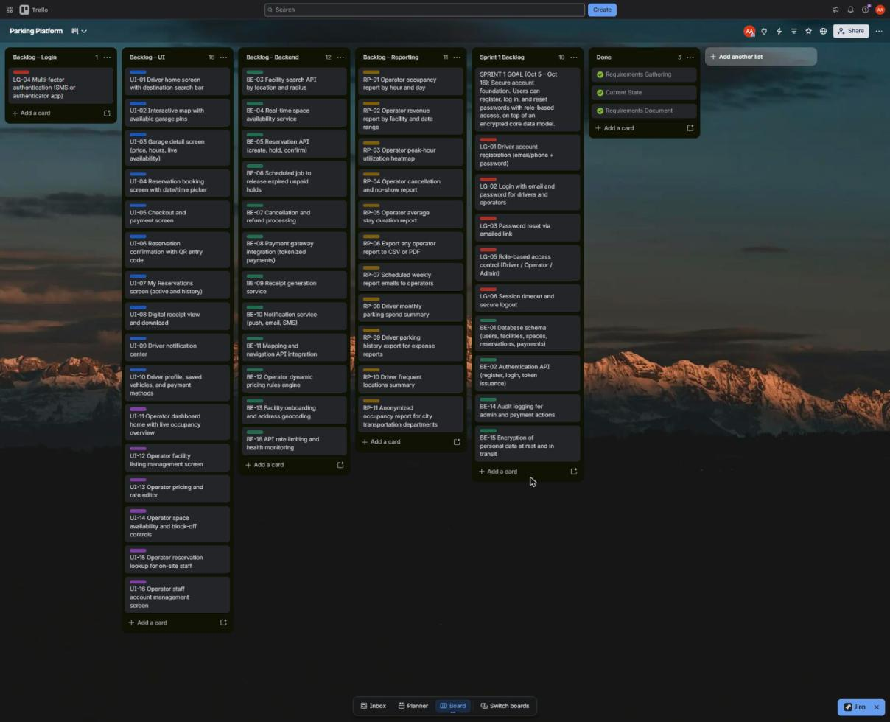
Figure 1. Smart Parking Platform Trello board showing the full product backlog, Sprint 1 Backlog, and Done lists.

4.2 Prioritization Approach
Backlog items were ordered using a dependency-first approach: work that other features cannot be built without is scheduled ahead of work that delivers visible functionality. Three principles guided the ordering:
- Foundations before features. Search, reservations, payments, and reporting all depend on user accounts, role-based access, and a stable data model. These are scheduled first so that later sprints are not blocked or forced into rework.
- Security built in, not bolted on. Because the platform stores personal and payment data, encryption (BE-15) and audit logging (BE-14) are delivered alongside the core data model rather than deferred to a hardening phase at the end of the project.
- Defer items with unmet dependencies. Multi-factor authentication (LG-04) remains in the backlog because SMS delivery relies on the notification service (BE-10), which is not yet built. It will be scheduled once that service is available.

4.3 Sprint 1 Plan
Sprint Goal (Oct 5 – Oct 16): Secure account foundation. Users can register, log in, and reset passwords with role-based access, on top of an encrypted core data model.
Sprint 1 runs for two weeks and commits nine backlog items: five from the Login category and four from Backend. Each item is traced back to the use cases in Section 3 so that the sprint delivers measurable progress against the SRS.
ID | Backlog Item | Category | Traces To | Acceptance Criteria
LG-01 | Driver account registration (email/phone + password) | Login | UC-01 | New driver can create an account; duplicate emails are rejected.
LG-02 | Login with email and password for drivers and operators | Login | UC-02, UC-11 | Valid credentials grant access; invalid credentials return a clear error.
LG-03 | Password reset via emailed link | Login | UC-02 | Reset link is emailed, expires after a set time, and works only once.
LG-05 | Role-based access control (Driver / Operator / Admin) | Login | UC-02, UC-11, UC-15 | Each role sees only its own screens and data.
LG-06 | Session timeout and secure logout | Login | UC-02 | Idle sessions expire; logout invalidates the session token.
BE-01 | Database schema (users, facilities, spaces, reservations, payments) | Backend | UC-01 – UC-17 | Schema is reviewed and migrated; supports all Sprint 1 items.
BE-02 | Authentication API (register, login, token issuance) | Backend | UC-01, UC-02, UC-11 | Endpoints are documented and covered by automated tests.
BE-14 | Audit logging for admin and payment actions | Backend | UC-15, UC-17 | Admin account actions are logged with user, action, and timestamp.
BE-15 | Encryption of personal data at rest and in transit | Backend | Non-functional (security) | Personal data is encrypted in storage; all traffic uses TLS.
Table 4. Sprint 1 committed backlog items with use case traceability and acceptance criteria.
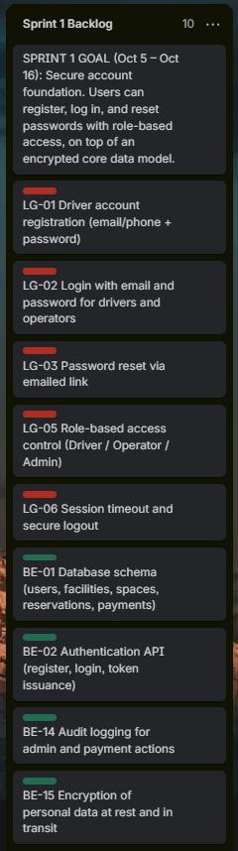
Figure 2. Sprint 1 Backlog list on the Trello board, with the sprint goal card at the top.

4.4 Alignment with the Project Schedule
Sprint 1 is deliberately aligned with the project schedule, in which the Database Design and Authentication & Authorization tasks are both planned for October 5–16. Matching sprint boundaries to scheduled tasks keeps the backlog and the timeline consistent: when a schedule task is reported complete, the corresponding backlog items should also appear in the Done list. Any slippage in one is therefore visible in the other.

4.5 Definition of Done
A Sprint 1 item moves to the Done list only when all of the following are true:
- Code is complete, peer-reviewed, and merged into the main branch.
- Automated unit tests pass, and the acceptance criteria in Table 4 have been verified by the Quality Assurance & Testing team.
- Security requirements are met: no personal data is stored or transmitted unencrypted, and admin actions are logged.
- API endpoints and schema changes are documented for the other delivery teams.

4.6 Look-Ahead: Sprints 2–4
The following sequence is provisional and will be refined at each sprint review based on Sprint 1 velocity and any changes to the SRS.
Sprint | Theme | Candidate Backlog Items
Sprint 2 | Find and reserve parking | BE-03, BE-04, BE-05, BE-11, BE-13, UI-01, UI-02, UI-03, UI-04
Sprint 3 | Pay, confirm, and notify | BE-06, BE-07, BE-08, BE-09, BE-10, LG-04, UI-05, UI-06, UI-07, UI-08, UI-09, UI-10
Sprint 4 | Operator tools and reporting | BE-12, BE-16, UI-11 – UI-16, RP-01 – RP-11
Table 5. Provisional sprint sequence for the remaining backlog.

